Appeal


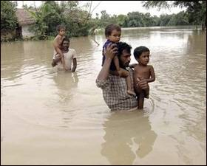
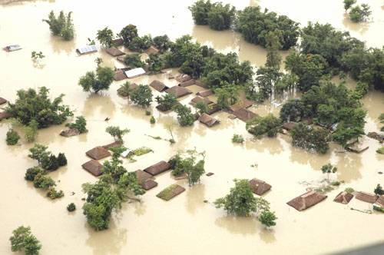

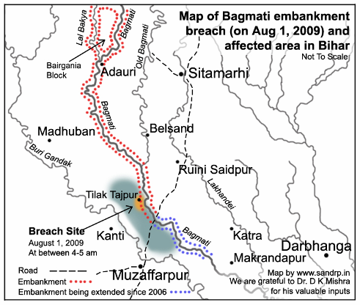
The flood situation has worsened in northern Bihar's Sitamarhi and Muzaffarpur districts as relief and rescue operations have been badly hit by continuous rains and rising water levels. The overflowing Bagmati River has submerged several villages and many villagers have been forced to leave their homes to seek a safer shelter. The river had breached its embankment on Saturday. Officials said the flood waters flowed down to Aurai and Katra blocks of Muzaffarpur district worsening the situation. The flood fury was tamed at the breach site at Tilak Tajpur village in Runisaidpur block after a relentless 24-hour work by nearly 800 labourers, who put boulders and nylon crators into the water to plug the breache..


Thousands homeless in Bihar due to floods
Patna: Thousands of people have been rendered homeless in Bihar's Sitamarhi district after the Bagmati river breached its embankment, flooding nearly 200 villages.
Those stranded in villages are living under the open skies without food and drinking water, waiting to be rescued. "We are hungry and our children are crying for food and milk, but nothing has been provided by the government though it is over 24 hours since the Bagmati river breached its embankment," Narayain Singh, one of the thousands of villagers taking shelter on embankments, told IANS via his mobile phone, which he feares might run out of charge soon.
"Till now, we have not been given any relief. We are without food and water," said Shyam Singh, another villager.

The water from the river entered more than 50 villages in Sitamarhi and Muzaffarpur districts. Muzaffarpur district magistrate Vipin Kumar said two rescue teams launched an operation on Sunday to bring relief to 70,000 victims.
More than 30,000 people in the worst-hit villages in Sitamarhi district like Tilak-Tajpur, Bharthia, Madhaul-Sani, Maisa-Farakpur, Balau-Kharauna, Basudev-Bishnupur, Barhaita, Sirkhiriya, Korlahia and Olipur had to leave their homes and take shelter on roads. The Sitamarhi-Muzaffarpur national highway (NH-77) was submerged in Kauahi, where the water was two feet deep, and in Bedaul. Chief Minister Nitish kumar made an aerial survey of flood-hit villages in Runnisaidpur (Sitamarhi) and Aurai (Muzaffarpur) blocks on Sunday. The CM reviewed the situation and ordered an inquiry into the breach. Flood waters submerged over 75 villages under Katra, Gaighat and Bandara blocks in the district, affecting a population of around three lakh. Given this context, Samajik Shaikshanik Vikas Kendra (SSVK), in light of its 25 years of experience in running relief and rehabilitation programmes, has prioritized for itself the need to intervene in four of the worst affected districts. We, at SSVK and it,s people,s organization Lok Shakti Sangathan have had a long standing organizational presence in the affected districts. In this hour of crisis, we look upon the need of our intervention as a moral imperative. Hence, we appeal to all concerned to contribute in whatever way they can. Most urgently, the food, clothing, shelter, drinking water and health needs of these helpless victims need to be addressed. So for the time being you could contribute in forms which address these needs. Contributions are welcome in cash or kind. We assure you of utmost transparency and accountability in making use of your contributions.
The people in the flood affected areas are suffering. It is our foremost duty to help these affected families during this calamity.


Flood situation worsens in Bihar as another river breaches Monday , Aug 03, 2009 at 1147 hrs
Patna: More than four lakh people were reeling under the impact of floods in Bihar with Lakhandei river breaching its embankments at two places, worsening the situation in Sitamarhi and Muzaffarpur districts on Monday. Lakhandei, swelled by swirling flood waters of turbulent Bagmati, breached the embankment in a stretch of over 200 metres near Tilak Tajpur in Sitamarhi district early on Monday, Tirhut Divisional Commissioner S M Raju said.
The water also destroyed its embankments at Baraitha Masjid and another place under Katra block in Muzaffarpur district late last evening. Flood waters submerged over 75 villages under Katra, Gaighat and Bandara blocks in the district, affecting a population of around three lakh, Raju said. Engineers and labourers were working day-and-night to plug the breach in stretches of 50 metres at two places on the embankment of Lakhandehi, he said.
Hence, this appeal is specifically directed at those donors, who are willing to extend support on this count. Our assurance is value added work for the support we get from them.
You can send the DD / Cheque also in favour of Samajik Shaikshanik Vikas Kendra

Priti Nath Jha & Shyam Kishore Singh , TNN 3 August 2009, Bagmati waters flood 2 more blocks
MUZAFFARPUR/SITAMARHI: The flood waters from Saturday’s breach of Bagmati river in Bihar submerged two more blocks of Muzaffarpur district adding thousands more to the nearly one lakh people rendered homeless.
This despite the flood fury in Runnisaidpur block in Sitamarhi district being tamed with the breach at Tilak Tajpur village more or less plugged on Sunday. About 800 labourers, who worked relentlessly for 24-hours, plugged a major portion of the breach by placing boulders and other materials by afternoon. The breach is expected to be totally plugged by Sunday midnight.

FCRA Account Details
( For foreign grant / donations please use this account )
Core Banking
STATE BANK OF INDIA, JHANJHARPUR
Bank Code: 03266
IFSC Code: SBIN0003266
Account No: 11462682338
General Account Details
( For Indian fund / grant / donations please use these accounts)
- STATE BANK OF INDIA, JHANJHARPUR
IFSC Code: SBIN0003266
Bank Code: 03266
Account No 11462685088
- Bank Name: INDUSIND BANK
Account Number: 0055F62519-001
IFSC Code: INDB0000055
Savings Account-Multi-City
Rajendra Ram Plaza Exhibtion Road
Patna-800001
For further details and clarifications, kindly contact us at the following:
- State Co-ordination cum Correspondence Office:
Samajik Shaikshanik Vikas Kendra (SSVK)
Lok Shakti Bhawan,
Opp: Ajay Nilayan Apartment,
Nageshwar Colony, Boring Road
Patna – 800001 (Bihar) India
Tele / FAX No. | + 91 - 612 - 2522077
Mobile: | + 91 - 94310 25801 / 9973161483
E-mail : | info @ ssvk.org
 | ssvkindia @ gmail.com
 | ngossvky86 @ yahoo.com
 | deepakbharti @ ssvk.org
Web : | http://www.ssvk.org
Registration Details
Name of the organization | Samajik Shaikshanik Vikas Kendra (SSVK)
Registration No. and date | Registered under: Society Registration Act XXI, 1860 by IG Registration, Govt. of Bihar at Patna Dated 5th April 1986 Registration No – 162 Year 1986-87
FCRA No. and date | Foreign Contribution Regulation Act .FCRA Regn No- 031290010 Dated-14 march 1990
Registered under 12A of Income Tax Act. | IT Act 12A of Income Tax Act. Regn No-12A/1-70/344- 48  dated 09.04.1991. Register Sl No -03
Registered under 80G Tax Exemption. | Section 80G of IT Act. 80G Tax Exempted. No-2808-09 dated10.09.2008  Valid from 01.04.2008 to 31.03.2011.
Registered under Tan | TAN (Tax deduction at source account number)  Tan No-PTNS02583A
Registered under Pan | PAN (Permanent account number) Pan No-AADTS2221G
FCRA Account Details  ( For foreign grant / donations please use this account ) | Core Banking  STATE BANK OF INDIA, JHANJHARPUR  Bank Code: 03266  IFSC Code: SBIN0003266  Account No: 11462682338
General Account Details  ( ForIndian fund / grant / donations please use these accounts ) | - STATE BANK OF INDIA, JHANJHARPUR  IFSC Code: SBIN0003266  Bank Code: 03266  Account No 11462685088  - Bank Name: INDUSIND BANK  Account Number: 0055F62519-001  IFSC Code: INDB0000055  Savings Account-Multi-City  Rajendra Ram Plaza Exhibtion Road  Patna-800001
Statuory Auditors | M/A G. Mandal And Co (Chartered Accountant, Near Indira Bhawan, West Boring Canal Road, New Punai Chak , Patna- 800023
www.ssvk.org
ssvkindia@gmail.com , info@ssvk.org , deepakbharti@ssvk.org

